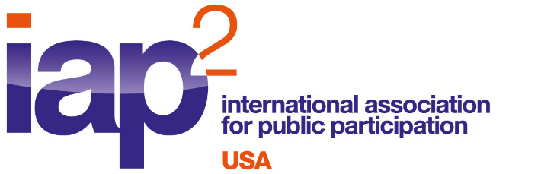
News Release: For more information:
September 26, 2023 Gail Madziar, IAP2 USA
gail@iap2usa.org, 517-676-4341
www.iap2usa.org
Lulu Feliciano Lulu.Feliciano@SFMTA.com,
415.646.2142

San Francisco Municipal Transportation Agency Receives National Honors
for San Francisco’s Central Subway Project
International Association for Public Participation (IAP2) USA awarded San Francisco Municipal Transportation Agency (SFMTA) the IAP2 USA Core Values Award in the Respect for Diversity, Inclusion and Culture Category for Honoring Cultural Diversity and Connecting Communities: San Francisco’s Central Subway. The winning entry was also forwarded to IAP2 International as Project of the Year for IAP2 USA.
SFMTA engaged diverse communities with differing needs in an expansive geographic area as they build San Francisco’s first new subway in 50 years. Public participation, much of it bilingual, allowed the team to work directly with potential users of this new subway line. Public input was critical in deciding the locations of four new stations, station design, and station elements such as gathering spaces, retail spaces, and a police sub-station. There were 10 years of planning and 10 years of construction, during which diverse communities from across San Francisco were able to shape the future of this new subway.

“The consistent commitment to outreach and involvement over a 20-year period is remarkable, through all the demographic changes, neighborhood transitions, changes in city administration and more recently the COVID pandemic. Most often, public participation occurs during the planning stage with only infrequent updates during construction,” said IAP2 USA President Heather Imboden. “SFMTA provided a very good explanation of the initial problem and how additional problems that came up over time were addressed. They made strong use of multilingual ambassadors from the community while providing funding for initiatives to help the community.”

The IAP2 Core Values Awards are presented each year to projects that best exemplify IAP2’s guiding principles. SFMTA received their award at the annual Gala held at the IAP2 North American Conference in Seattle, WA on September 14, 2023.

Founded in 1992, the International Association for Public Participation advocates for and supports the practice of Public Participation, which is based on the premise that people affected by a decision have a right and expectation to have their opinion, position and interests heard and considered. IAP2 USA now has more than 2,500 members.
##

